PF Lab 09 Tasks
Name: Muhammad Sarim Abidi
Roll No: 25K-0090
Section: BAI-1A

Task 1:

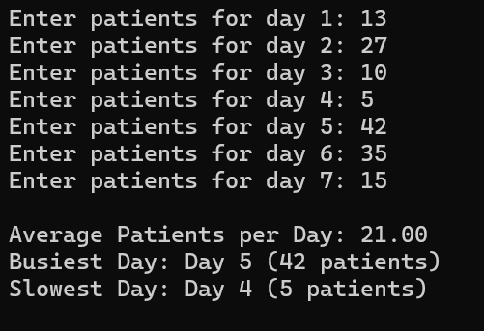

Task 2:
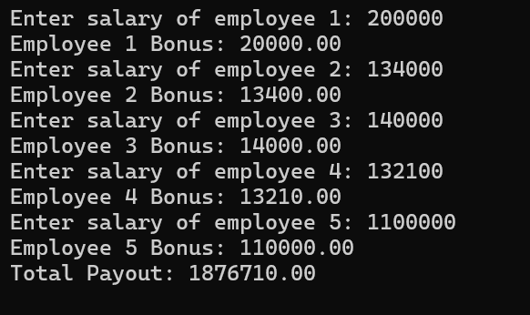

Task 3:

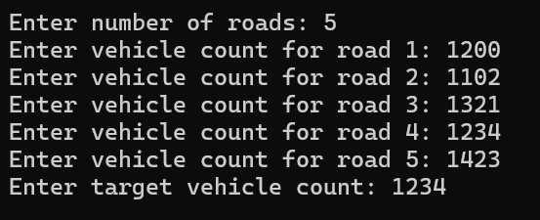

Task 4:

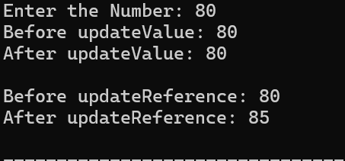

Task 5:

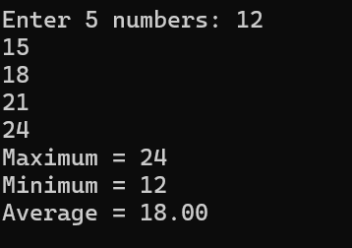

Task 6:

